SUPPORT YOUR CHEERLEADER: T-shirt Order Form
Name: __________________________________________
Size: Small ________ Medium ___________ Large ___________ XL ___________
2XL ($1 more) ____________3XL ($2 more) ________________
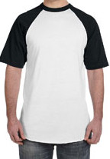
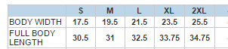

E-mail Address: _________________________________________
Phone #: (_______) __________-___________
Shirt Personalization: $25.00 – Includes the design you choose plus a name and number on the back!
- Option (A): “CLAW MOM” with or without glitter OR
‘CLAW DAD” without glitter
- Option (B): “Duluth Cheer Dad” no glitter OR
“Duluth Cheer Mom” with or without glitter
- Option (C): “Cheer Mom – WILDCATS” with or without glitter OR
“Cheer Dad – WILDCATS” without glitter
- Personalize any of the above “mom” or “dad” to Grandma, brother, uncle, etc. w/ or w/out glitter
Make check payable to Donna Wright or use Venmo to pay Donna Wright @ donna-wright-11

Please provide any comments or info to clarify order. Please feel free to call Donna with any questions or special requests! 678-469-5475

____________________________________________________________________________________________________________________________________________________________________________

- Make check payable to Donna Wright or use Venmo to pay Donna Wright @ donna-wright-11
- Please use the back of this order form to provide any comments or info to clarify order. Please feel free to call Donna with any questions or special requests! 678-469-5475!

OPTION A (MOM OR DAD) OPTION B (MOM OR DAD) OPTION C (MOM OR DAD)

